YR WYTHNOS WEDDI AM UNDEB CRISTNOGOL 2025
WEEK OF PRAYER FOR CHRISTIAN UNITY 2025
As part of our Pentecost Week of Prayer events for 2025
Bangor CYTUN / Churches Together invites you to join us on

A City Centre Prayer Walk, Litter Pick and Picnic
on Saturday May 31st 2025 from 10.30am until 12.30pm

This sheet summarises the Bangor Cytun City Centre Prayer Walk with litter-pick and picnic which took place on the above date. The purpose in reproducing this here is to give an opportunity to anyone who was not able to attend on the day to use the materials to enter into a prayerful virtual experience on their own at home or with friends. For this reason photographs have been inserted at the relevant points, so that people can get an idea of the landscape and area we covered. Alternatively, some may wish to actually walk the route themselves and use the prayer resources and written commentary in the same way the main group did.

For those who fall into the latter category the following risk assessment is still relevant: The walk involves some gradual uphill stretches and some steep downhill stretches that are accessible to pushchairs but will not be accessible to wheelchairs. Most of the paths are either tarmacked or good quality hardcore; many are off-road but there is some road walking including one very short stretch along a road without pavements. Stewards in High Vis jackets will be at the front and back of the group. A full risk assessment has been prepared and the route walked carefully.

The walk is not long in distance – about 1.56 km / just under a mile. We will make four stops along the route to pray. There will be some set prayers but also the opportunity for ex tempore prayer. There will be people equipped to litter pick along the route as an expression of our desire to care for God’s creation. All are invited if they can to stay at the end for a picnic. Please bring your own food!

10.30am Meet in the car park at Emaus chapel, Love Lane

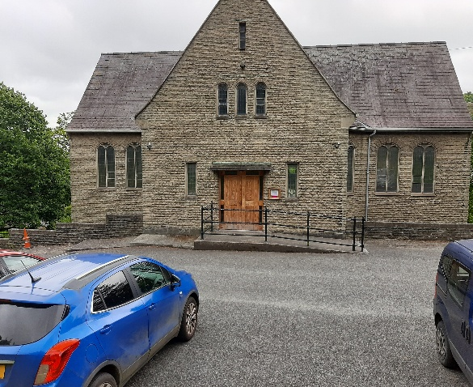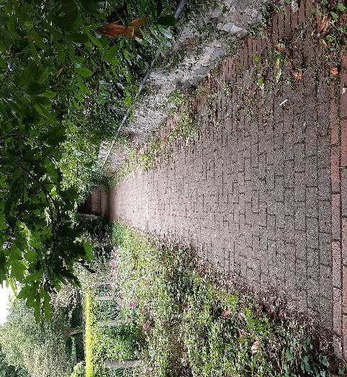

10.45 Gathering prayer and depart Emaus
i) Short explanation of the route and how it will be split up with various stations with prayer times along the way and chances for people to pray ex tempore; explain that we will be using some material from the Week of Prayer booklet at each stop.

ii) Flag up any risk assessment or health and safety or safeguarding issues that need to be addressed

iii) Introduction to gathering prayer: (prayer and reflection material that is to be shared is printed here in both languages. These could be used alternately or on occasions both versions read out)
The first theme of the Week of Prayer is the parenthood of God who rules the universe. So as we gather to begin our walk today we offer a prayer from Day 1 of the material (pages 10 -13):

Gweddi
Bendithiwn di, O Arglwydd, Dad y goleuni:
oddi wrthyt ti y deillia popeth da a phob rhodd berffaith.
Ti a wnaeth y byd a’r hyn oll sydd ynddo,
ti yw Arglwydd nef a daear.
Creaist yr holl bobloedd sy’n trigo ar y ddaear.
Ar eu cyfer hwythau fe sefydlaist drefn amser a ffiniau eu trigfan.
Yng nghalonnau bodau dynol, plannaist ddyfnder tragwyddoldeb.
Rho i’r undod hwnnw y mae ein hunanoldeb wedi’i dorri enedigaeth newydd,
yn dy Eglwys ac yn yr un byd o’n cwmpas.
Dduw bob cysur, galwa ni i’th ddilyn a gwna waith ein dwylo yn gadarn.
Molwn di drwy Iesu Grist, dy unig Fab, yng nghymundeb yr Ysbryd Glân. AMEN.

Prayer
We bless you, O Lord, Father of lights:
from you descends every good thing and every perfect gift.
You have made the world and all that it contains,
you are the Lord of heaven and earth.
You created all the peoples that dwell on the earth.
For them you established the order of time and the boundaries of their space.
In the heart of human beings, you have placed the depth of eternity.
Rebirth in us that unity that our selfishness has fractured
in your Church and in the one world around us.
God of all consolation, call us to follow you and make firm for us the work of our hands.
We praise you through Jesus Christ, your only-begotten Son, in the communion of the Holy Spirit. AMEN.

10.55 – 11.05 We leave Emaus and walk to the First Station: Praying for the natural world
Yr Ardul Natur / Conservation Woodland, below Neuadd Rathbone
Prayers based on Day 2 of the Week of Prayer ‘Creation as God’s work’ (pages 14-17)

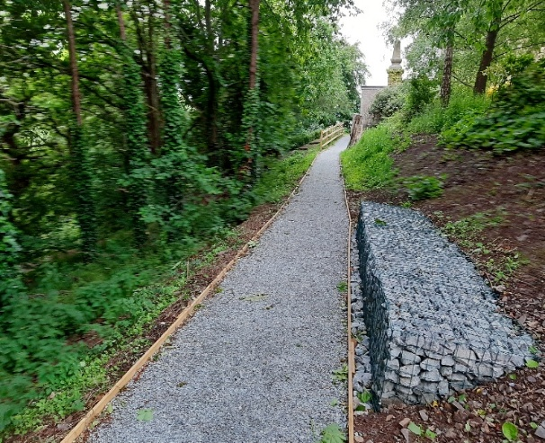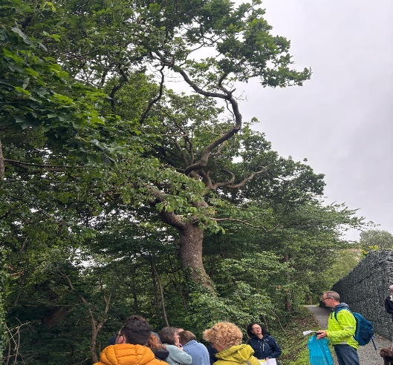

Introduction: Isaac of Nineveh, a seventh century bishop and theologian from Syria, wrote that the “first book given by God to rational beings is the nature of created things. Instruction by means of ink was added after the transgression (ie the Fall).” The words that we are using today from the Week of Prayer booklet are printed in ink on a page, yet Bishop Isaac says such words can only dimly represent the mark that God has put on creation. If we are not able to marvel at God’s work as Creator, then we cannot marvel.

This small woodland, owned by the University, has in the past few years been restored and transformed to support a vibrant ecosystem where people and nature can coexist. It sits here between the University buildings in Upper Bangor and the city centre below. By 2024 over 1500 trees and 15,000 bulbs had been planted to regenerate this space.

We have chosen to stand here to pray because from here you can see at least two of the many efforts made to encourage wildlife to thrive – there are bird boxes which are reasonably easy to spot and bat boxes which are much harder; there are also what are called hibernacula, winter places of refuge, such as holes in the ground, leaf and woodpiles, which offer habitats to a variety of fauna in order to enhance the biodiversity of this area.

So we stand here first for a moment in silence to appreciate the nature around us and to listen to its sounds and then if anyone wants to offer a prayer in praise of God’s creation or asking for its protection from harm please feel free to do. Then we’ll finish by offering the prayer from Day 2 in the booklet (pages 14-17):

Prayer
We praise you and give you thanks, God of steadfast love, for the great signs of your favour
and your mercy for the whole creation. You have made all things:
you declared them to be good, and you love all that brings life.
We proclaim, O Lord, your glory seen in the immense starry vastness of the universe
and in the smallest seed of life.
We give thanks for the works of your hands and the creation of all people.
Blessed are you for the air that gives us life.
Blessed are you for the earth that nourishes us.
Blessed are you for the water that quenches our thirst.
Blessed are you for the fire that warms us.
Lord God, Father of lights, strengthen our hearts in expectation and hope
as we work for unity and together seek the harmony of all creation.
Let us be burning lamps, until the day of the coming of your Son in glory,
with all his saints in the everlasting kingdom.
Blessed are you, now and forever, and to the ages of ages. AMEN.

Gweddi
Molwn di a diolchwn i ti, Dduw cariad diysgog, am arwyddion rhyfeddol dy ffafr
a’th drugaredd drwy’r holl greadigaeth. Gwnaethost bopeth,
a datgan bod pob dim yn dda, ac rwyt yn caru popeth sy’n dod â bywyd.
Cyhoeddwn, Arglwydd, dy ogoniant a welwn yn ehangder serennog y bydysawd
ac yn yr hedyn lleiaf o fywyd.
Diolchwn i ti am waith dy ddwylo ac am greu yr holl bobloedd.
Bendigedig wyt ti am yr awyr sy’n rhoi bywyd i ni.
Bendigedig wyt ti am y ddaear sy’n ein maethu.
Bendigedig wyt ti am y dŵr sy’n torri ein syched.
Bendigedig wyt ti am y tân sy’n ein cynhesu.
Arglwydd Dduw, Dad y goleuni, nertha ein calonnau mewn disgwyliad a gobaith
wrth i ni weithio dros undod a cheisio ynghyd gynghanedd yr holl greadigaeth.
Gad i ni fod yn llusernau llachar hyd ddydd dyfodiad dy Fab mewn gogoniant,
gyda’i holl saint yn y deyrnas dragwyddol.
Bendigedig wyt ti yn awr ac am byth, a hyd yn oes oesoedd. AMEN.

11.15 – 11.25 We move on to the Second Station: Praying for the whole city of Bangor
Main Arts lookout point, Penrallt Road/Lower Penrallt Road junction
Prayers based on Day 8 of the Week of Prayer ‘Waiting for the Kingdom’ (pages 64-67)

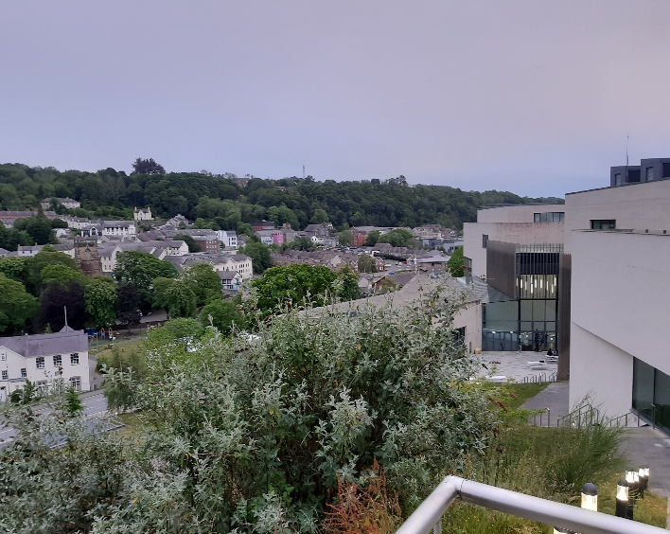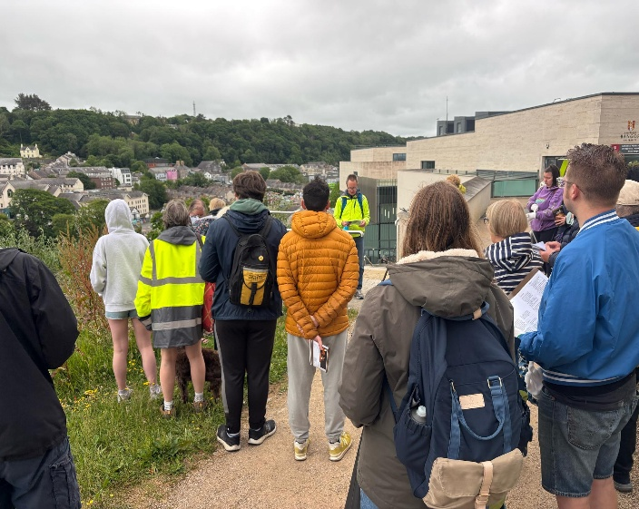

Introduction: This seemed to us as good a place as any to look over and pray over the whole City of Bangor. We marvel at how in the last 1500 years a small settlement established by St Deiniol, somewhere down there in the valley between where we are now and Bangor mountain, has grown and spread across this area. All the churches in Bangor CYTUN find their home somewhere in this small city or its outlying neighbourhoods; God has placed us here together to minister together to the needs of this place and its people and we give thanks for the opportunity to do God’s will in this way.

Day 8 in the booklet focuses on what the writers call ‘Waiting for the kingdom’ / ‘Disgwyl am y Deyrnas.’ It reminds us that love is at the heart of the Kingdom of God here on earth as well as in heaven; and as fellow Christians here in this city we are called to look for signs of hope in the community around us and to embody the signs of the coming kingdom in our lives, by living lives of love and service to others as Christ taught us. Dorothy Solle wrote: ‘Christ made God manifest by making invisible people visible – the poor, all those deprived of their rights.’ How can we make known God’s love to this city?

Once again let’s stand here quietly to begin with to take in this view beneath us and then if anyone wants to offer a prayer for the people of Bangor and the needs of our community in its most general aspect then please feel free to do, bearing in mind that one of our later stations is specifically focused on the High Street of the city and the people and businesses we find there. Then we’ll finish by offering the short reflection from Day 8 in the booklet (pages 64-67):

Myfyrdod
Pa lawenydd sydd mewn gobaith? Pa lawenydd sydd mewn undod?
Rydyn ni’n llwglyd ar y ffordd, ac yn Nuw cawn ein maethu.
Pryd fyddwn ni’n fodlon? Dim ond pan fyddwn ni’n bwydo ein chwiorydd a’n brodyr,
yn estyn llaw at y ddynoliaeth, yn croesawu’r dieithryn.
Pan fyddwn yn cyffwrdd â’r greadigaeth wrth i ni wylio’n ddisgwylgar
am yr adeg pryd fydd cyfiawnder a heddwch yn cusanu.
Cadwch eich lampau ynghyn, byddwch effro.
Oherwydd mae llawenydd mewn undod, mae llawenydd mewn gobaith.
Yn y gobaith hwnnw y canwn “alelwia”. Amen

Reflection
What joy is there in hope? What joy is there in unity?
We are hungry on the road, and in God we are nourished.
When shall we be satisfied? Only when we feed our sisters and brothers.
Reaching out to humanity, welcoming the stranger.
Touching creation as we watch and wait.
For a time when righteousness and peace kiss.
Keep your lamps burning, keep watch.
For there is joy in unity, there is joy in hope.
In this hope we sing “alleluia”. Amen

11.35 – 11.45 We move down the hill to the Third Station:
Praying for ourselves and the people of the world
Plaza in front of Pontio Arts Centre & Memorial Arch, beside Deiniol Road
Prayers based on Day 3 of the Week of Prayer ‘The Incarnation of the Son’ (pages 18-21)

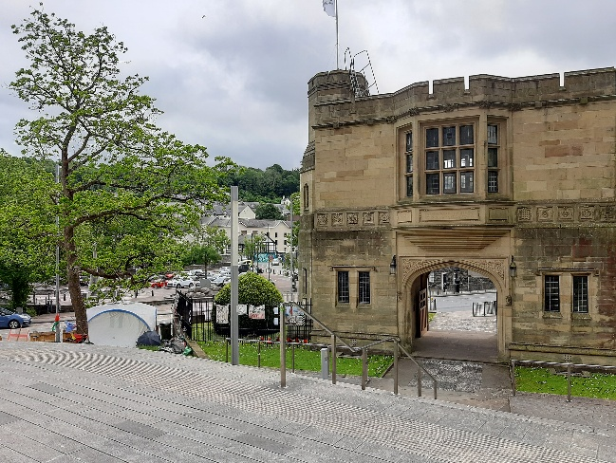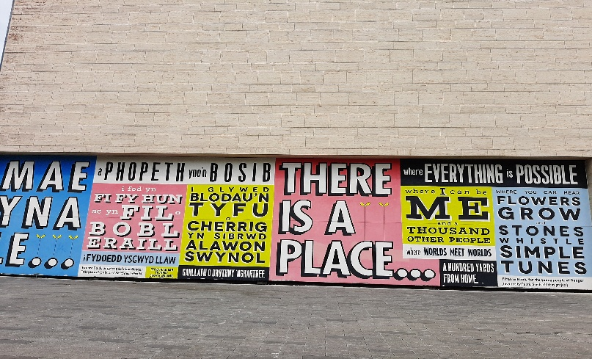

Introduction: We’ve come here to this very busy space in our city to reflect on some of the things that surround us here. Below us is the Memorial Arch, opened in 1923, called more accurately the North Wales Heroes Memorial Arch. Inside the arch is a room bearing the names of 8,500 soldiers sailors and air crew who fought and died in World War One. Next to it is the Peace camp that has been here for well over a year making sure that people who pass by on foot or in their cars know that somebody has not forgotten the people of Gaza in their hour of need. Then over here is this huge mural, a message to the young people of Bangor to say there is still hope in our world, there is hope not only that we can each grow up to become the people we want to be but also that there is hope that worlds and cultures can meet without the need for conflict and mistrust but in celebration, because ‘all things are possible.’ We might like to add the two words ‘with God’ at the start of that phrase.

Day 3 of the Week of Prayer booklet reminds us that it is into such a world that Jesus came; a world where terrible things are done by one group against another, sometimes in the name of freedom or security. Where billions of human lives are not lived abundantly but are prevented from flourishing by poor education or poor health or lack of opportunity or violence or war. Yet into such a world Christ came, taking on flesh and becoming one of us and one with us.

The American poet Madeleine L’Engle in her poem entitled ‘First Coming’ expresses this most powerfully:

God did not wait till the world was ready, till nations were at peace.
God came when the heavens were unsteady and prisoners cried for release.

God did not wait for the perfect time. God came when the need was deep and great.
God dined with sinners in all their grime, turned water into wine. God did not wait

till hearts were pure. In joy God came to a tarnished world of sin and doubt.
To a world like ours, of anguished shame God came, and God’s light would not go out.

In the Go and Do section of Day 3 we are asked to reflect on where in our daily routines do we meet Jesus. And this plaza here asks of us how do I balance my needs to flourish and be fulfilled with the needs of those in our world who know only suffering and disappointment?

Once again let’s stand here quietly to reflect on these things for a moment and then if anyone wants to offer a prayer for this world that God so loved that he sent his only Son to be its Saviour then please feel free to do so. Then we’ll finish by offering the short prayer from Day 3 in the booklet (pages 18-21):

Prayer
Word of God, teach us how to love.
May we allow you to share our life in all things.
Lord God, our Father, draw our eyes to you
so that together as your people, we may walk from darkness
embracing the light of your face revealed to us in Jesus, your beloved Son, our brother and Saviour,
who lives alongside You, at your right hand now and for eternity. AMEN.

Gweddi
Air Duw, sydd i’n dysgu sut i garu.
bydded i ni ganiatáu i ti rannu yn ein bywydau ym mhob ffordd.
Arglwydd Dduw, ein Tad, tyn ein llygaid atat ti
fel y gallwn fel dy bobl gerdded ynghyd o dywyllwch
i gofleidio goleuni dy wyneb a ddatguddiwyd i ni yn Iesu, dy annwyl Fab, ein brawd a’n Gwaredwr,
sy’n byw ar y cyd â thi, ar dy ddeheulaw, yn awr a hyd dragwyddoldeb. AMEN.

11.55 – 12.05 We cross the road and move on to the Fourth Station:
Praying for the churches and our local community
Outside Bangor Cathedral, where Glanrafon meets the High Street

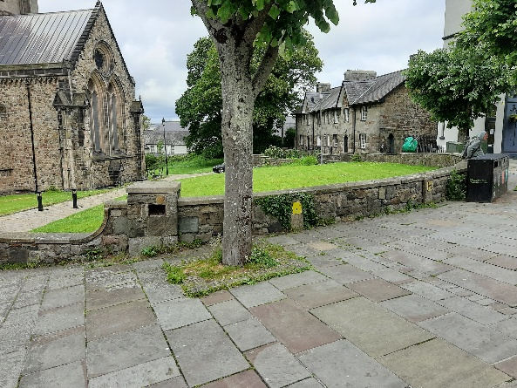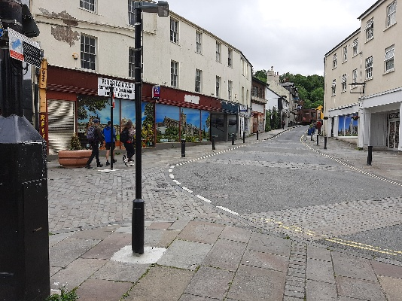
Prayers based on Day 6 of the Week of Prayer ‘The Church: Community of Believers’ (pages 56-59)

Introduction: Day 6 in the Week of Prayer reminds us that if we are to bring healing to our community then we too must be whole and we must find ways of living out our mission and service not just within our churches and to our own people, but beyond our upper rooms, out on the Emmaus roads, sharing our stories with those we meet in the places that need to be transfigured by the love of Jesus.

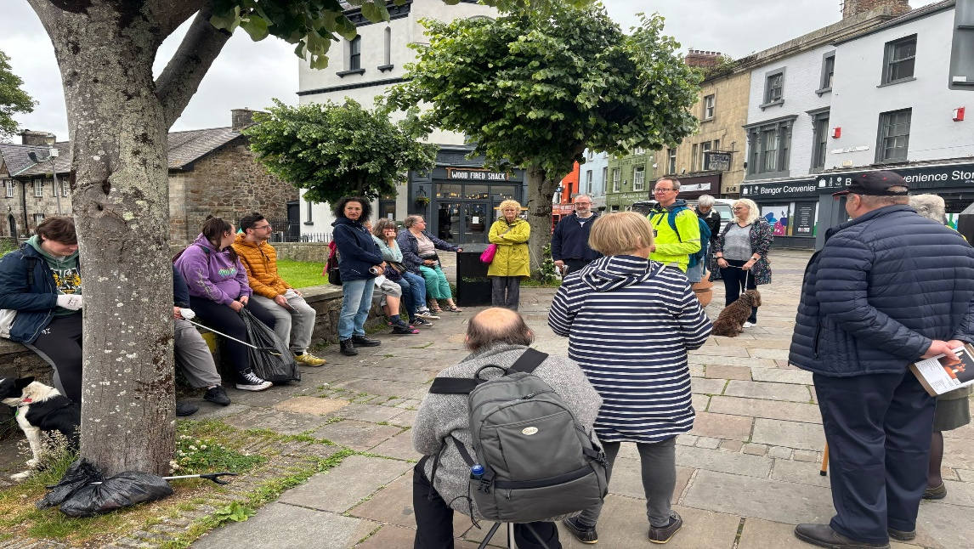

So we come here to the very heart of the city, where the cathedral, the most obvious physical symbol of God’s presence for the people of this city, stands in the mist of the bustle of the market place and the High Street. What can we do to turn this symbol into a meaningful daily reality in the lives of the people, who walk along this throughfare every day? How can the shops and businesses be graced with the Spirit of God to become places which help to bind our community together? How can the livelihoods of the people who work on our High Street be transformed and be transforming, so that the city centre is not primarily about making money but about enriching lives.

The booklet reminds us that we are so privileged, as members of the Body of Christ in this city, to be part of such rich and diverse church communities and that are called to work together to make disciples of all people, who can then in turn help God’s kingdom become real in this place.

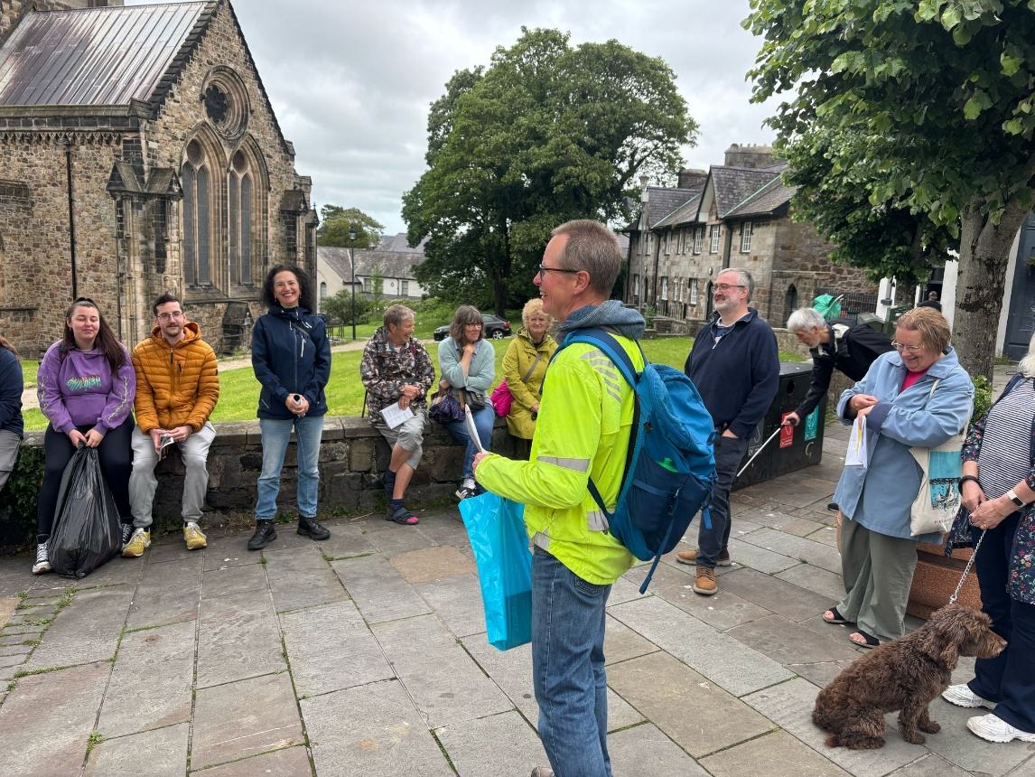

We’re going to pause for a moment once more and then invite anyone who wants to offer a prayer for the lives and livelihoods of the people who work in our city centre to do so. Then we’ll finish by offering the short prayer from Day 6 in the booklet (pages 56-59):

Gweddi
Dduw ein teithiau,Grist ein glannau,
Ysbryd y gorwelion diderfyn, Drindod gadarn, tywys ni tuag at undod.
Heria ni i fentro o’n goruwchystafelloedd a’n llecynnau diogel,
i fod yn negeswyr goleuni a thangnefedd.
Cynnau ni â goleuni dy gariad a’n cymoid â ni ein hunain, â’n gilydd ac â thi
wrth i ni ymgodymu â gwarth ymrannu.
Impia dangnefedd, cariad a thosturi wrth ein cenhadaeth a’n gwasanaeth.
Rhwyma â thangnefedd unrhyw aelod toredig fel y gallwn fynd allan i’r byd
a byw yn ffordd Iesu er mwyn yr holl greadigaeth.
AMEN

Prayer
God of our journeyings, Christ of our shorelines,
Spirit of endless horizons, beckon us towards unity.
Challenge us to step out of our upper rooms and safe spaces,
to be bringers of light and peace.
Imbue us with the light of your love, reconciling us to ourselves, to each other and to you
when we confront the scandal of division.
Graft peace, love and compassion into our mission and discipleship.
Bind with peace any broken limb that we might go into the world
and live the way of Jesus for the sake of all creation.
AMEN

12.10 – 12.20 We move around the cathedral to our final place for a closing prayer:
The Bible Garden, Bangor Cathedral

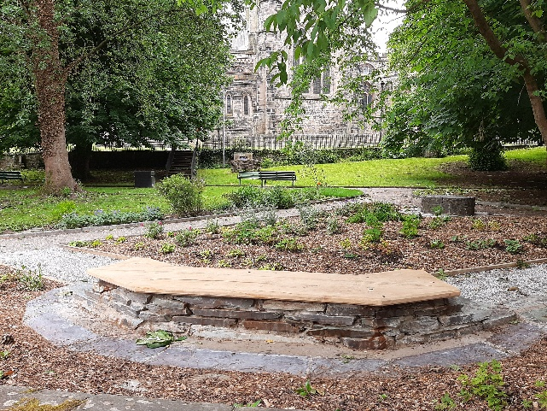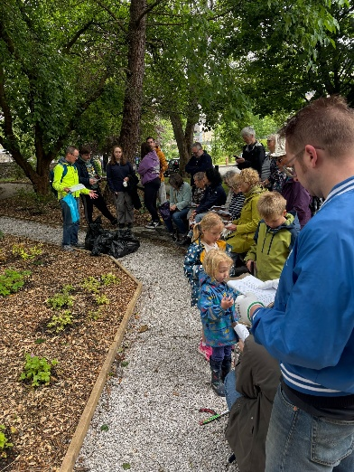
Prayer based on Day 5 of the Week of Prayer ‘The Holy Spirit, breath of God’ (pages 52-55)

Prayer
God, Giver of Life, Light of the World, Breath of Heaven,
the one God three times holy – Blessed are you past, present and future.
We confess our common faith in you.
Let us rejoice in the Spirit, who renews the face of the earth and draws us towards unity.
Forgive us when our breath is distasteful.
Enflame us with your Pentecost fire, to speak the truth of the gospel that brings freedom and life.
Awaken our prayers and give them flesh as we work with you,
to make well and full, the whole of creation. AMEN

Gweddi
Dduw, rhoddwr bywyd, goleuni’r byd, anadl y nefoedd,
yr un Duw deirgwaith sanctaidd – bendigedig wyt ddoe, heddiw ac yfory.
Cyffeswn ein ffydd gyffredin ynot ti.
Llawenhawn yn yr Ysbryd, sy’n adnewyddu wyneb y ddaear ac yn ein cymell tuag at undod.
Maddeua i ni pan fydd ein hanadl yn ddiflas.
Cynnau ni â thân y Pentecost, i lefaru gwirionedd yr efengyl sy’n dod â rhyddid a bywyd.
Deffra ein gweddïau a’u gwisgo â chnawd wrth i ni gydweithio â thi
i wneud yn dda ac yn gyflawn y cread cyfan. AMEN

Finally, an opportunity to pray over the litter we have collected (5 large bag bags of it)– giving thanks for those who have done the picking and inviting God to take our small efforts as a symbol of the desire for us to share in God’s wider mission and ministry of healing within the city.

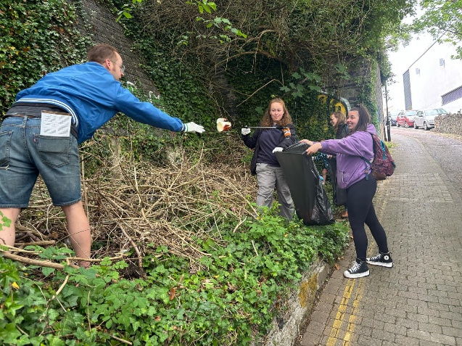

12.25 We move onwards to our picnic site:
Neuadd Y Dref playground and picnic area beside Y Storiel
Once the group has reached the picnic area people are free to stay, join us, or return back to Emaus if they have left their vehicles there and need to leave.
Sue Eckersley, John Hay & Nick Sissons, St John’s Methodist Church

